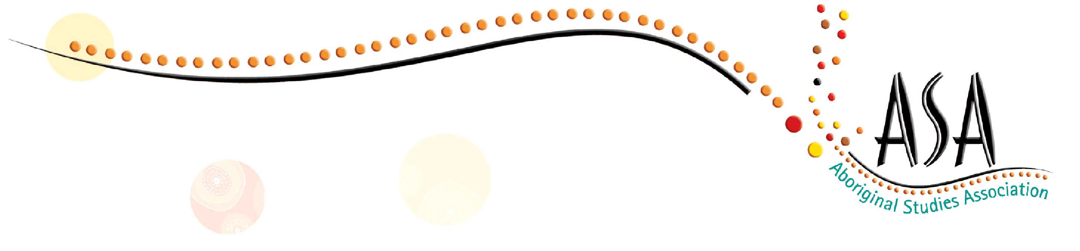

2016 ABORIGINAL STUDIES ASSOCIATION CONFERENCE

UNIVERSITY OF SYDNEY

Friday 2 December 2016

9:00 am—3:30pm

KEYNOTE: Elizabeth Wymarra Black Comedy

Workshops by teachers for teachers

- Aboriginal Studies K-12

- Aboriginal Perspectives Across the Curriculum

- Aboriginal Community Engagement

$175 including 2017 Membership

Payment MUST be finalised by the 25 November 2016

For more information contact: davelardner@aecg.nsw.edu.au

This is a BOSTES Accredited event  Completing the 2016 Aboriginal Studies Association Annual Conference will contribute 5 hours of QTC Registered PD addressing 1.4.2, 2.4.2, 6.2.2, 6.4.2, 7.4.2 from the Australian Professional Standards for Teachers towards maintaining Proficient Teacher Accreditation in NSW. The University of Sydney - Faculty of Education and Social Work is endorsed to provide QTC Registered Professional Development for teachers accredited at Proficient Teacher and Highly Accomplished Teacher. | 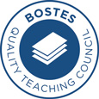

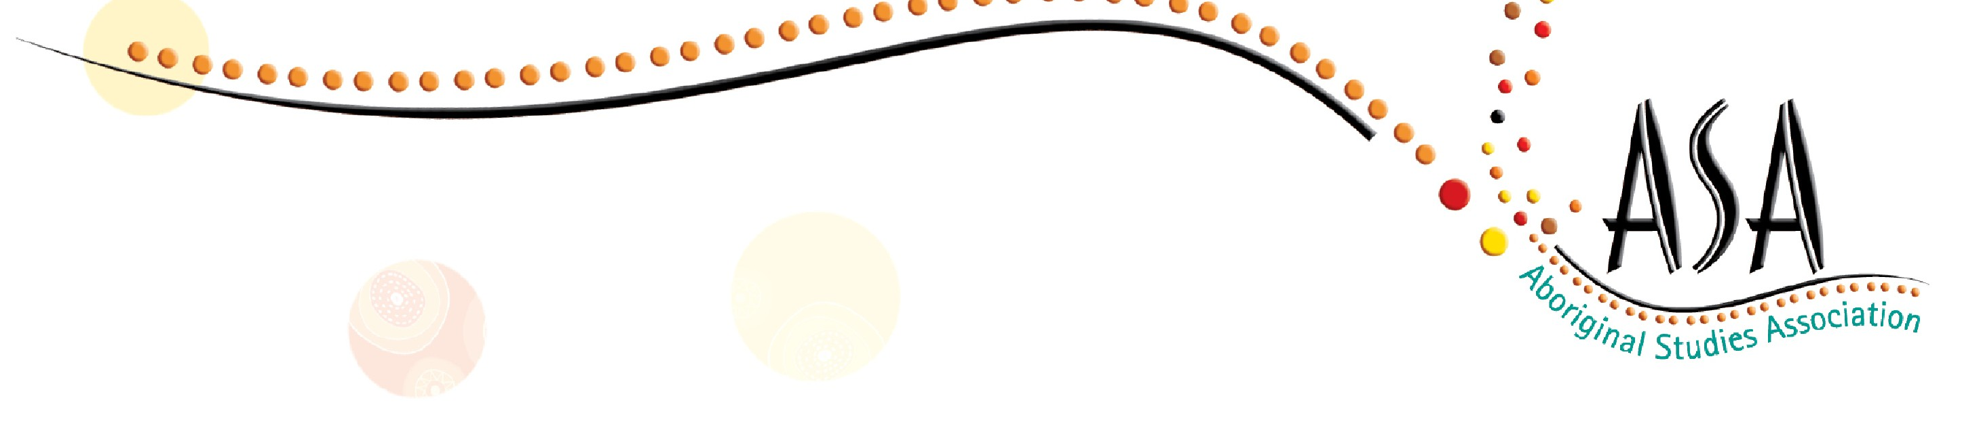

REGISTRATION FORM and TAX INVOICE
This form, when completed, can be used as a Tax Invoice.

ABORIGINAL STUDIES ASSOCIATION CONFERENCE 2016

The University of Sydney - Faculty of Education and Social Work is endorsed to provide QTC Registered Professional Development for teachers accredited at Proficient Teacher and Highly Accomplished Teacher.

NAME: | POSITION:
ASA MEMBER NUMBER OR NEW: | EMAIL:
LOCATION: | POSTAL ADDRESS:
PHONE NO: | FAX NO:
DIETARY REQUIREMENTS:
TOTAL AMOUNT $175 (includes ASA membership for 2017)

Please note that all payments should be made to through the NSW AECG (ABN: 29 271 072 930) and INCLUDE GST
Payment Method: EFT  National Australia Bank BSB: 082 387  Account Number: 517687052 Account Name: NSW AECG  Reference: ASA.full name | Payment Method: CHEQUE  Please make payable to: NSW AECG Mail to: ASA Conference  c/- NSW AECG  37 Cavendish St, Stanmore NSW 2048
To Register, FAX or EMAIL this form to ASA Conference – NSW AECG on 02 95503361 or dave.lardner@aecg.nsw.edu.au so that your details can be added to the Conference Participant List

The ABORIGINAL STUDIES ASSOCIATION greatly appreciates the generous support of the NSW ABORIGINAL EDUCATION CONSULTATIVE GROUP, UNIVERSITY OF SYDNEY and the NSW DEPARTMENT of EDUCATION, ABORIGINAL EDUCATION AND COMMUNITY DIRECTORATE.

